1.В **layout** (**header, footer(если есть)**) поставить **условие**, при котором **link-search** будет **только на home-page** (т. е. - **отсутствует** на страницах **product, cart**):

**resources\views\shop\layout.blade.php**

**@if (\Request::is('/'))**

<li><a href="#" class="search-nav">Search <img src="{{ asset('public/img/core-img/search.png') }}" alt=""></a></li>

**@endif**

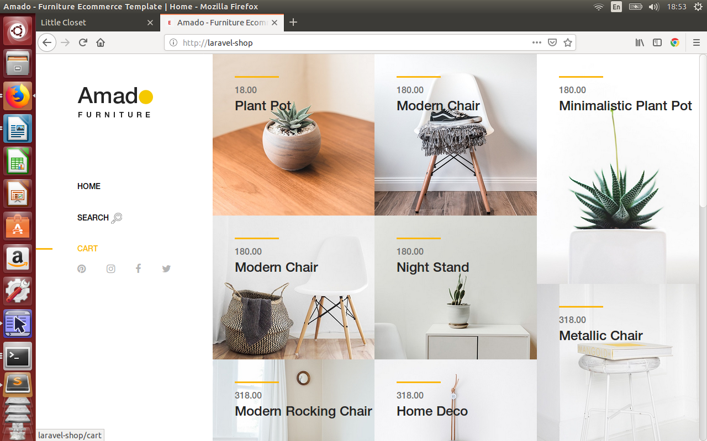

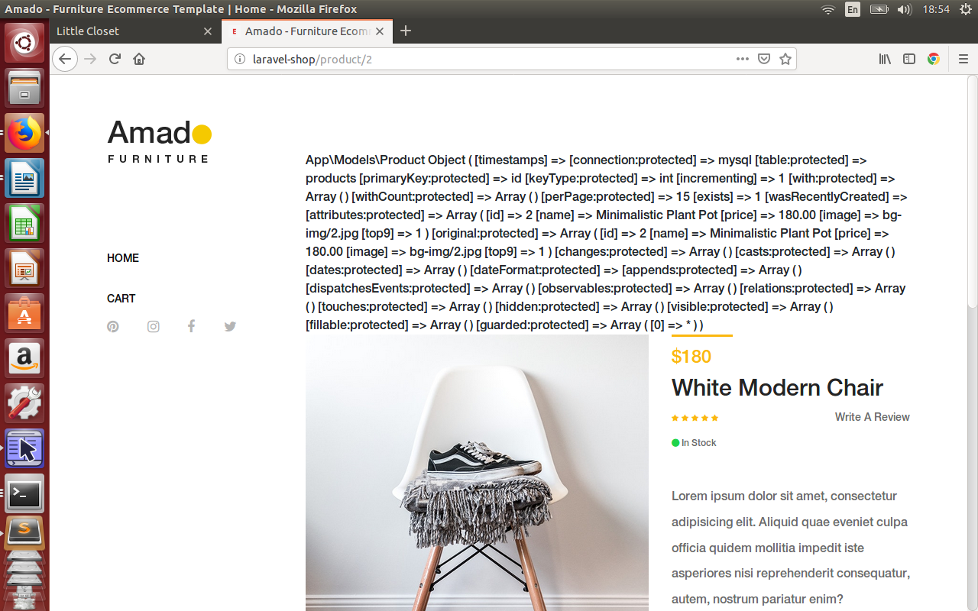

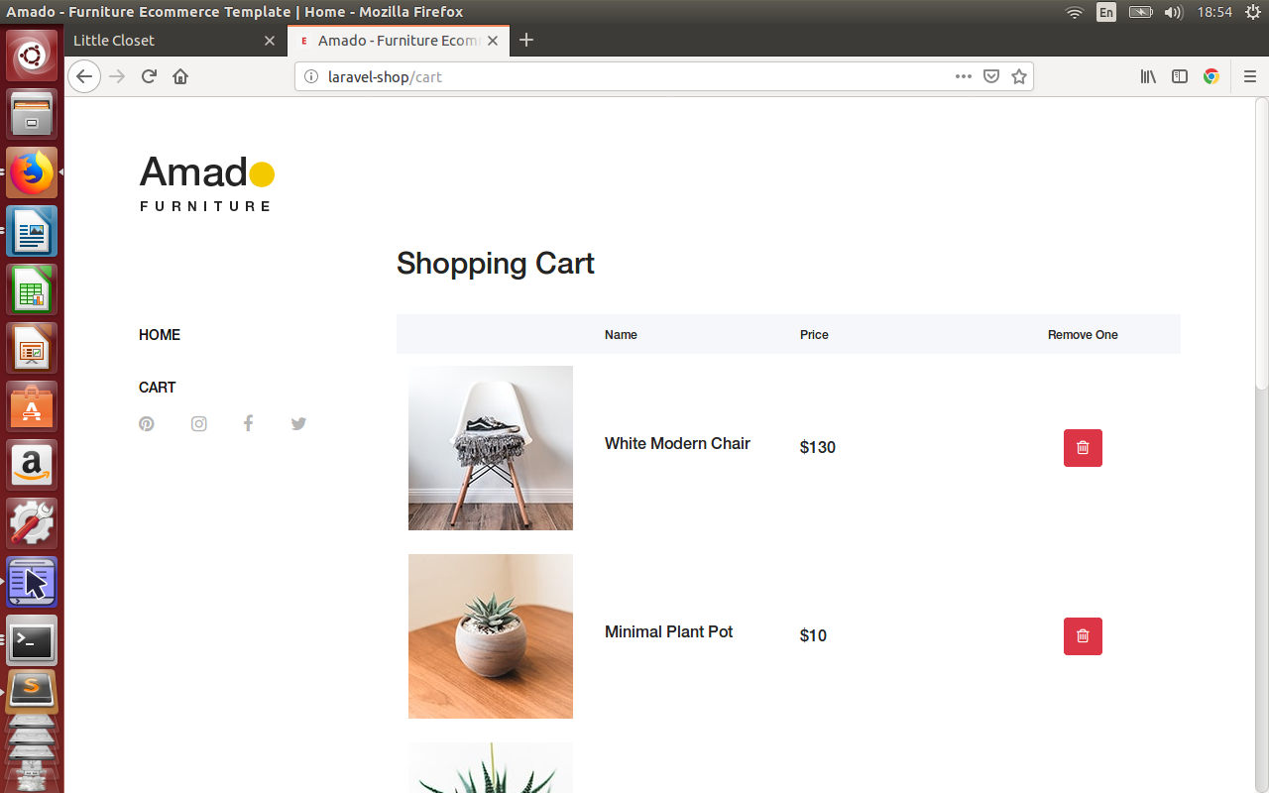

2.Реализовать **ajax-search** по **контексту** введенного значения в таблице **products** (поле **name**):

**resources\views\shop\index.blade.php**

@section('js')

<script src="**{{ asset('public/js/main.js') }}**"></script>

<script>

**$(document).ready(function(){**

**$('.button_search').click(function(){**

**BaseRecord.search($('#search').val());**

**});**

**});**

</script>

@endsection

**public/js/main.js**

var BaseRecord={

**search: function(value){**

**var ajaxSetting={**

**method: 'get',**

**url: '/', //vagrant ./**

**data: {**

**search: value,**

**},**

**success: function(data){**

**//alert(data.table);**

**$('.amado-pro-catagory').html(data.table);**

**},**

**};**

**$.ajax(ajaxSetting);**

**},**

};

**app\Http\Controllers\ShopController.php**

public function index(**Request $request**, ShopRepository $repository)

{

$products = $repository->funcSelect(**$request**);

**// Ajax response**

**if ($request->ajax()) {**

**return response()->json([**

**'table' => view("shop.brick-standard", ['products' => $products])->render(),**

**]);**

**}**

return view('shop.index', ['products' => $products]);

}

**app\Repositories\ShopRepository.php**

public function funcSelect($request)

{

$query = $this->model

->select('id', 'name', 'price', 'image')

->orderBy('price', 'asc');

**if(isset($request->search)) $query->where('name', 'like', '%' . $request->search . '%');**

return $query->get();

}

